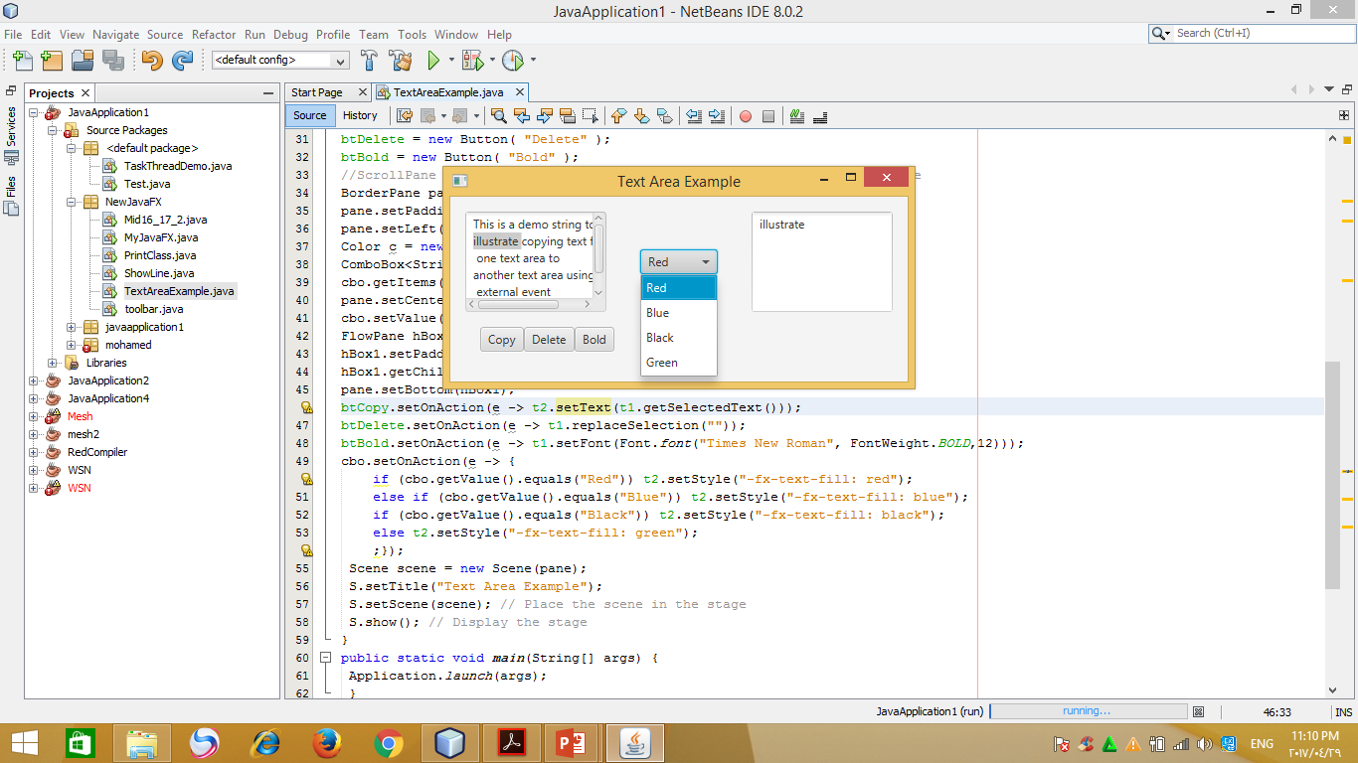

public class TextAreaExample extends Application{

TextArea t1, t2;

Button btCopy,btDelete,btBold;

public void start(Stage S) {

String demo = "This is a demo string to\n" +

"illustrate copying text from \n one text area to \n" +

"another text area using an\n external event\n";

t1 = new TextArea( demo ); // create textArea 1

t1.setPrefColumnCount(10);

t1.setPrefRowCount(5);

t2 = new TextArea( ); // create textarea 2

t2.setPrefColumnCount(10);

t2.setPrefRowCount(5);

btCopy = new Button( "Copy" ); // create copy button

btDelete = new Button( "Delete" );

btBold = new Button( "Bold" );

BorderPane pane = new BorderPane();

pane.setPadding(new Insets(15, 15, 15, 15));

pane.setLeft(t1); pane.setRight(t2);

ComboBox<String> cbo = new ComboBox<>();

cbo.getItems().addAll("Red", "Blue","Black", "Green");

pane.setCenter(cbo);

cbo.setValue("Red");

FlowPane hBox1 = new FlowPane();

hBox1.setPadding(new Insets(15, 15, 15, 15));

hBox1.getChildren().addAll(btCopy,btDelete,btBold);

pane.setBottom(hBox1);

btCopy.setOnAction(e -> t2. appendText (t1.getSelectedText()));

btDelete.setOnAction(e -> t1.replaceSelection(""));

btBold.setOnAction(e -> t1.setFont(Font.font("Times New Roman", FontWeight.BOLD,12)));

cbo.setOnAction(e -> {

if (cbo.getValue().equals("Red")) t2.setStyle("-fx-text-fill: red");

else if (cbo.getValue().equals("Blue")) t2.setStyle("-fx-text-fill: blue");

else if (cbo.getValue().equals("Black")) t2.setStyle("-fx-text-fill: black");

else t2.setStyle("-fx-text-fill: green");

;});

Scene scene = new Scene(pane);

S.setTitle("Text Area Example");

S.setScene(scene);

S.show();

}